**Data Base Systems I**

**CSC322**

**Final Project Report**

**Title: Payroll Management System**



|  |  |
| --- | --- |
| **Name:** | *Manahil Fayyaz, Tayyaba* |
| **Registration Number:** | *FA21-BCE-039, FA21-BCE-093* |
| **Class:** | *BCE-5A* |
| **Instructor’s Name:** | *Asad Ali Malik* |

**Table of Contents**

Introduction: 3

ER Diagram 3

Creation of Database: 4

Creation of Tables: 4

Alteration in Tables: 7

Insertion of data in tables: 7

Conclusion: 13

**Payroll Management System**

# **Introduction:**

The proposed project aims to develop a robust Payroll Management System using MySQL as the database management system. This system will streamline and automate the payroll processes within an organization, ensuring accurate and efficient salary management for employees. The Payroll Management System will encompass 10 key tables, each designed to capture specific information vital for payroll processing.

**Objectives:**

* Efficiently manage employee salary details.
* Automate payroll calculations, including deductions and bonuses.
* Provide a user-friendly interface for payroll administrators.
* Generate detailed and customizable payroll reports.
* Ensure data security and integrity through MySQL database features.

# **ER Diagram**

An Entity-Relationship (ER) diagram is a visual representation of the relationships between different entities in a database schema. In the context of the provided tables, we can construct an ER diagram to illustrate the relationships between the entities. The "Employees" table serves as the central entity, and other tables such as "Salary_Details," "Attendance," "Deductions," "Bonuses," "Tax_Details," "Payroll_Log," "Departments," "Designations," and "Users" establish various associations with the employees.

The "Employees" table has a primary key, employee_id, which is referenced as a foreign key in other tables, creating relationships. For instance, the "Salary_Details" table links to "Employees" through the employee_id foreign key, detailing aspects like basic salary, allowances, deductions, and net salary. Similarly, the "Attendance," "Deductions," "Bonuses," "Tax_Details," and "Payroll_Log" tables all reference the employee_id, capturing diverse information such as attendance records, types and amounts of deductions, bonuses granted, tax rates, and payroll log details.

The "Departments" and "Designations" tables provide additional context to employees' roles, with relationships established via department_id and designation_id. Lastly, the "Users" table, which contains information about system users, is linked to the "Employees" table through the user_id, establishing relationships based on roles such as admin, payroll_manager, and employee. The ER diagram visually depicts these connections, aiding in understanding the structure and relationships within the database.

**Tables**

## **Creation of Database:**

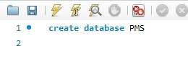

## **Creation of Tables:**

1. **Employee:**

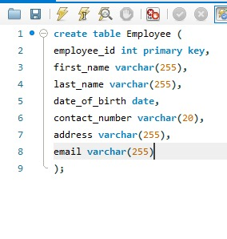

The Employee table is created to store employee details such as ID, name, birth date, salary, address. The primary key constraint is set on employee_id to ensure unique identification of employees.

1. **Salary_detail:**

The "Salary_Details" table is connected to the Employees table through the employee_id foreign key. It stores specific salary-related information, such as basic_salary, allowances, deductions, and net_salary. This table is crucial for maintaining and tracking the financial aspects of employee compensation.

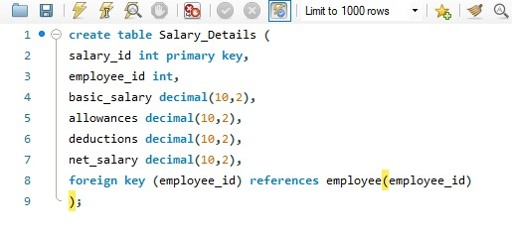

1. **Attendence:**

The "Attendance" table is linked to the Employees table through the employee_id foreign key and records information related to employee attendance. It includes details like attendance_id, date, and hours_worked, providing a comprehensive view of employee attendance records.

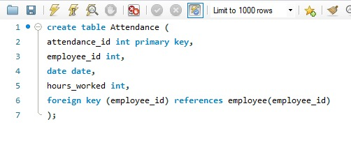

1. **Deductions:**

The "Deductions" table, connected to the Employees table via the employee_id foreign key, manages various types of deductions for employees. It includes deduction_id, deduction_type, and amount columns, allowing for the tracking of specific deductions affecting an employee's net salary.

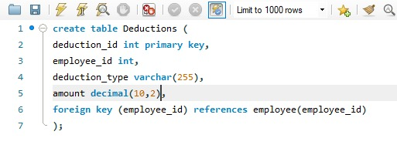

1. **Bonuses:**

The "Bonuses" table is associated with the Employees table through the employee_id foreign key and records information about bonuses granted to employees. It includes bonus_id, bonus_type, and amount columns, providing a structured way to document bonuses awarded to individuals.

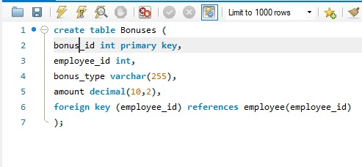

The "Tax_Details" table, linked to the Employees table via the employee_id foreign key, manages tax-related information. It includes tax_id, tax_rate, and other tax-related details, facilitating the tracking of taxes applicable to individual employees.

1. **Tax_details:**

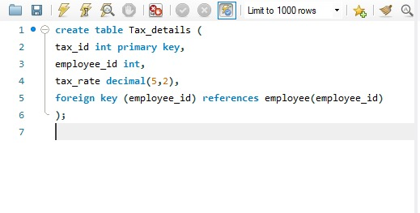

1. **Payroll_log:**

The "Payroll_Log" table is connected to the Employees table through the employee_id foreign key and tracks various payroll-related actions. It includes log_id, action, date, and details columns, providing an audit trail for changes and updates related to employee payroll.

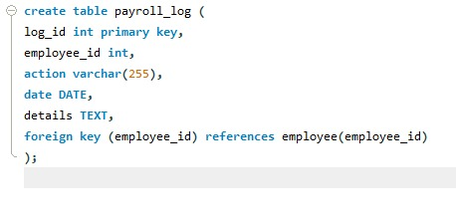

1. **Departments:**

The "Departments" table maintains information about different departments within the organization. It includes department_id and department_name columns, facilitating the organization and categorization of employees based on their respective departments.

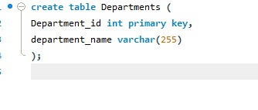

1. **Designations:**

The "Designations" table stores information about different job designations within the organization. It includes designation_id and designation_name columns, allowing for the classification of employees based on their roles.

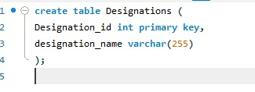

1. **Users:**

The "Users" table manages user authentication and authorization information. It includes user_id, username, password, and role columns, supporting the implementation of user access control with roles such as admin, payroll_manager, and employee.

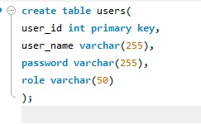

1. **EmployeeLeave:**

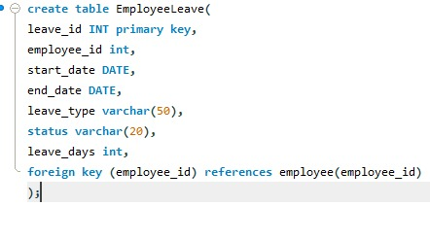

## **Alteration in Tables:**

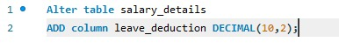

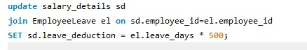

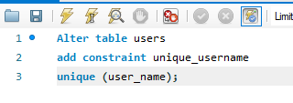

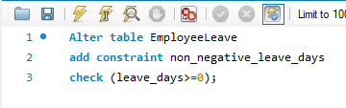



# **Insertion of data in tables:**

1. **Employee:**

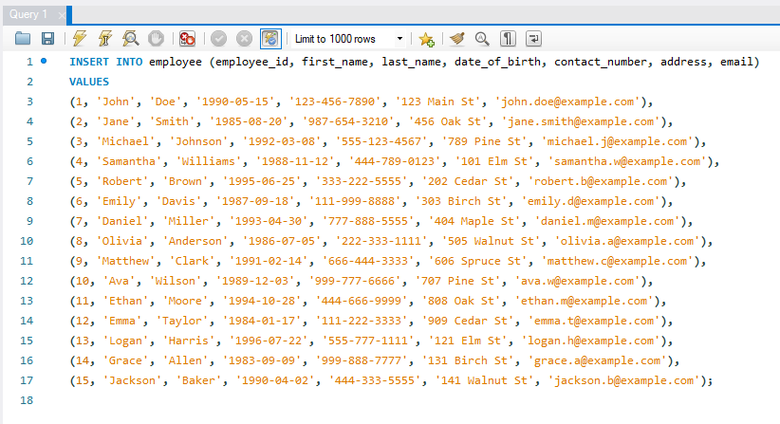

1. **Salary details:**

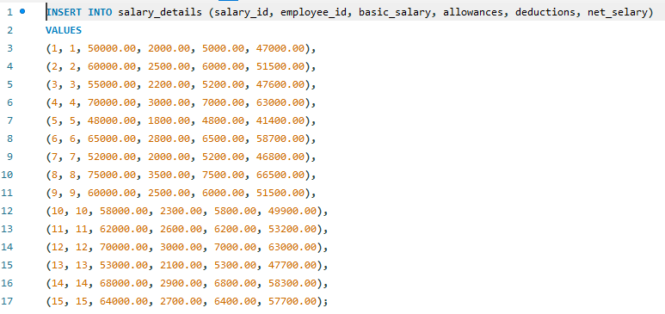

1. **Deductions:**

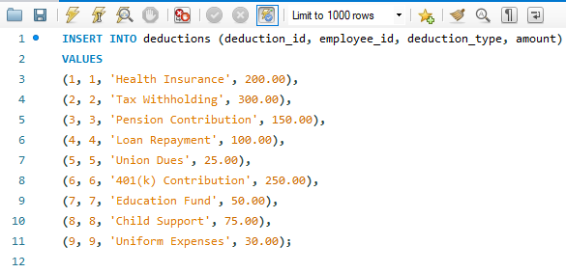

1. **Attendance:**

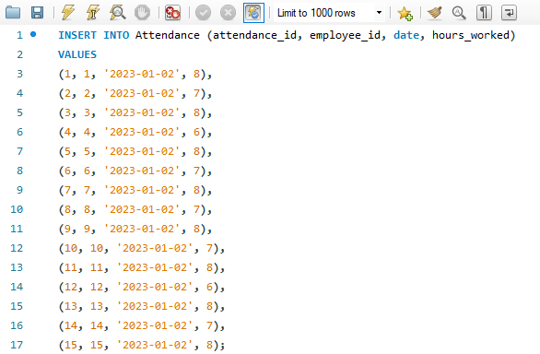

1. **Payroll log:**

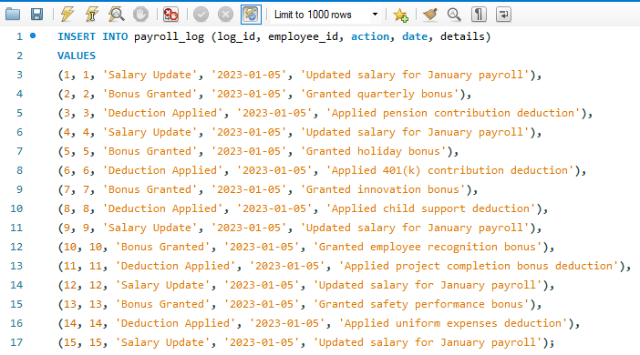

1. **Tax details:**

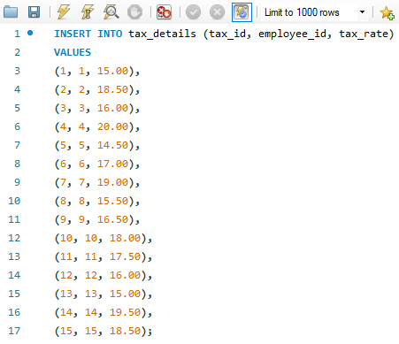

1. **Departments:**

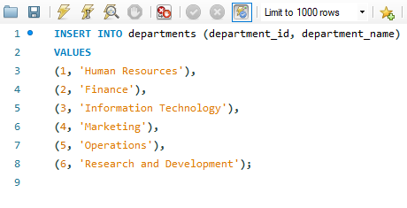

1. **Designations:**

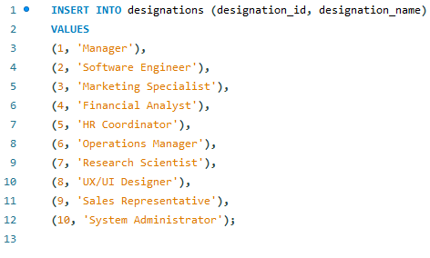

1. **Users:**

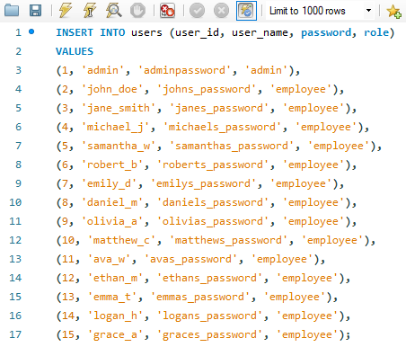

1. **EmployeeLeave:**

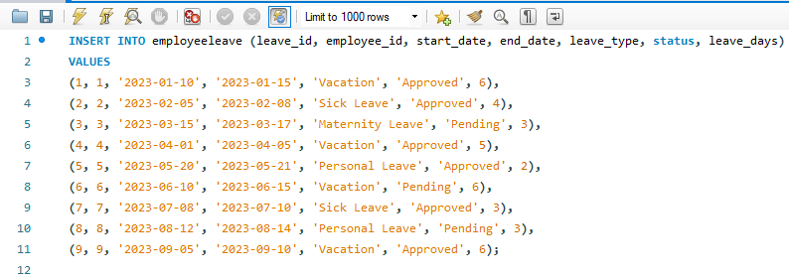

1. **Bonuses:**

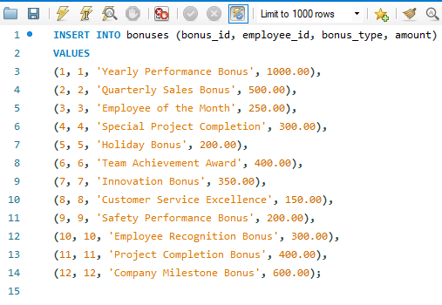

***For the construction of ER-diagram, we did the following changes in the tables:***

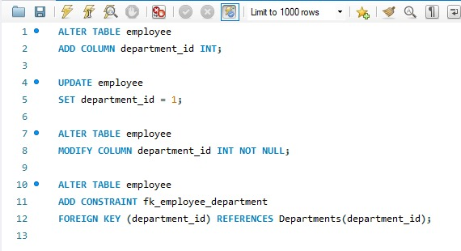

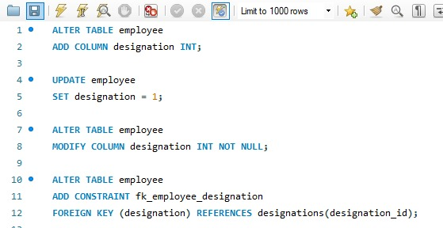

**Diagram:**

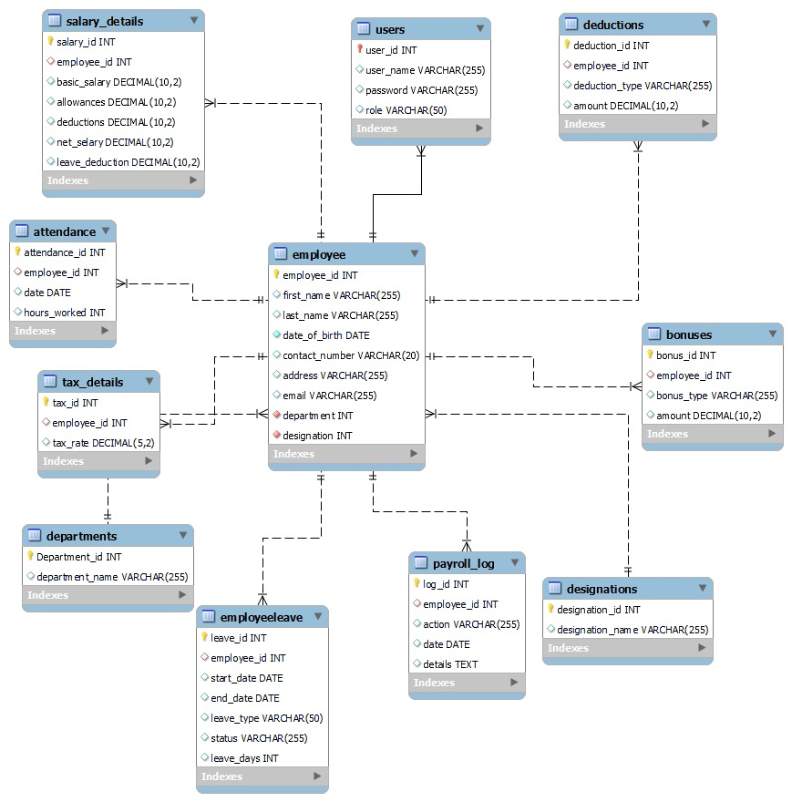

# **Conclusion:**

In conclusion, the proposed Payroll Management System encompasses a comprehensive set of tables designed to efficiently manage employee-related information, payroll processing, and administrative functions. The inclusion of various tables such as Employees, Salary_Details, Attendance, Deductions, Bonuses, Tax_Details, Payroll_Log, Departments, Designations, and Users provides a robust framework for handling diverse aspects of payroll management.

The proposed system promotes efficiency, accuracy, and transparency in payroll processing, contributing to the overall organizational effectiveness. It addresses the complex landscape of payroll management by incorporating diverse functionalities and relational structures. The careful design of tables allows for scalability and adaptability to evolving organizational needs.

By implementing this Payroll Management System, organizations can streamline payroll processes, enhance data accuracy, and improve overall employee management. The inclusion of role-based access ensures data security, while the interconnected tables facilitate a holistic approach to payroll administration. In conclusion, this project proposal lays the foundation for an advanced and user-friendly system that meets the dynamic requirements of modern payroll management.

-----------------------------